Content:
- How to set up a pay as you go account for copilot studio. See: https://www.youtube.com/watch?v=G2i5hw40eWU

- Solve the “You currently do not have a user license that allows you to publish in Copilot Studio” issue.
- Onboarding new users, and publishing agents on their teams.

Common Issue: You currently do not have a user license that allows you to publish in Copilot Studio. Please contact your administrator to upgrade your license or enable the necessary permissions. [Learn more]

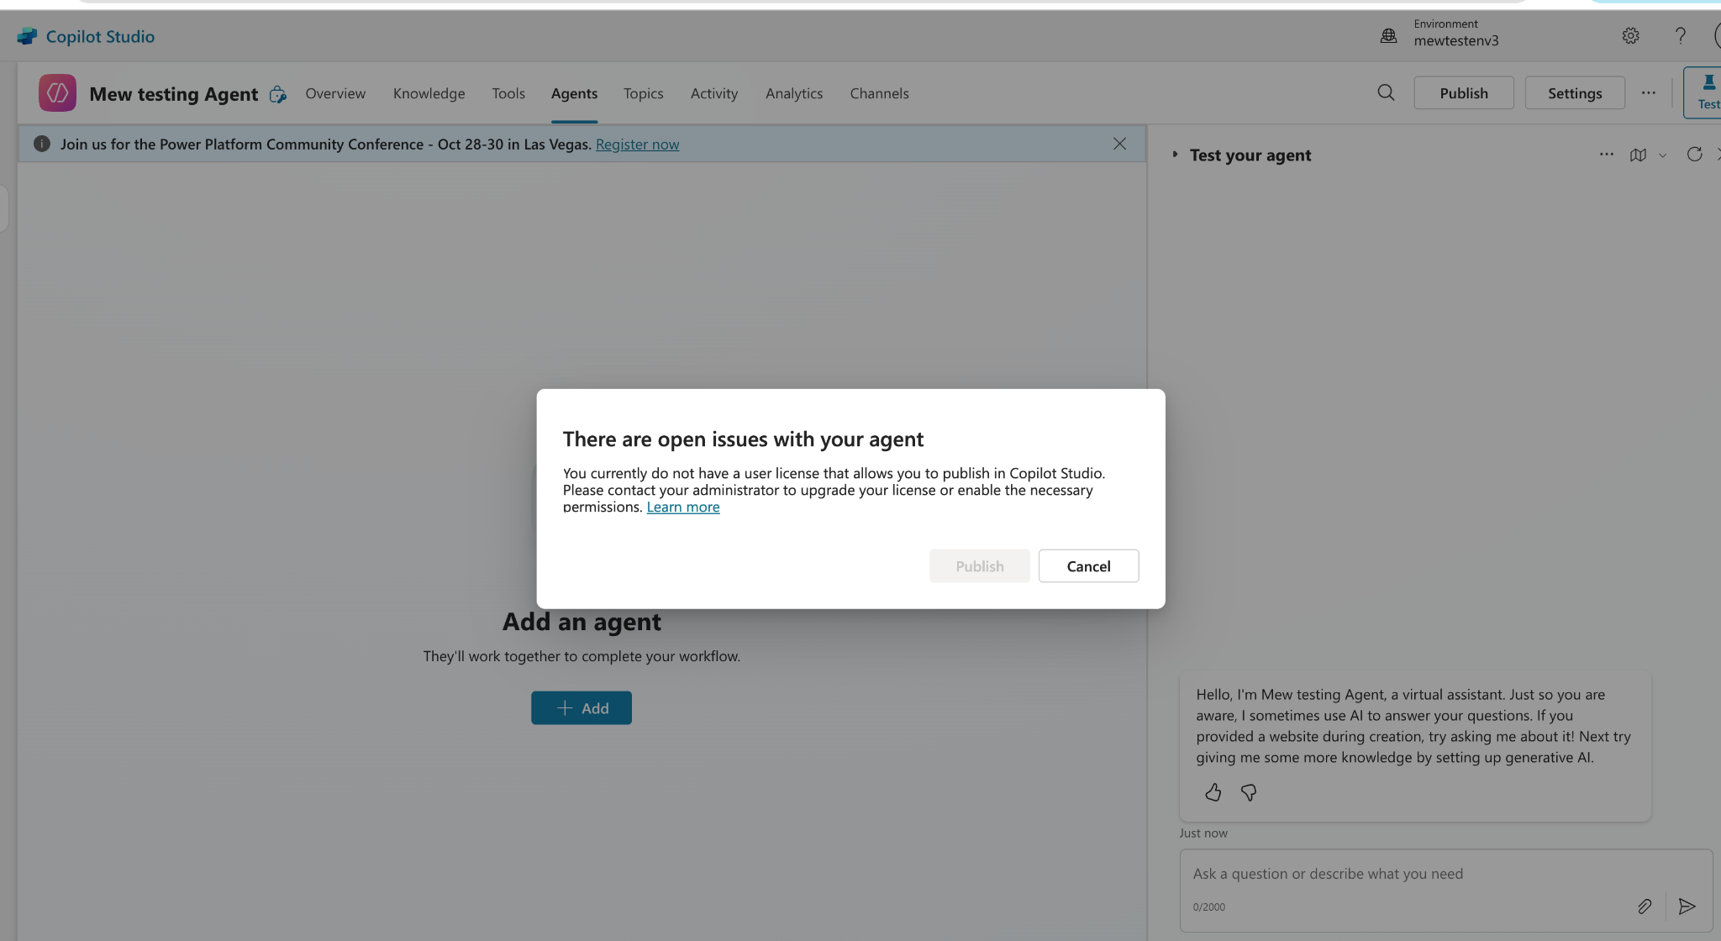

Solution:
“Copilot Studio authors” role in Power Platform admin center
- Create the security group in Azure portal/Entra and assign users to the group.
- In the Power Platform admin center, assign the security group to the Copilot Studio author setting.

Let’s Create the security group in Azure portal/Entra and assign users to the group.
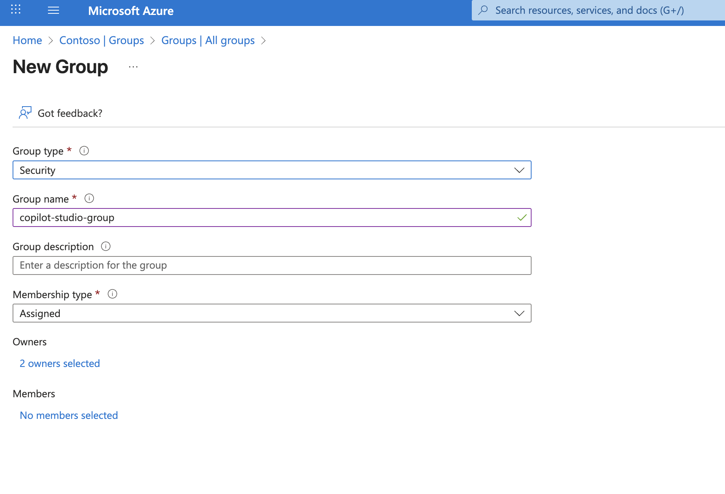
Ensure the required user is added. Here we will add githubuser5
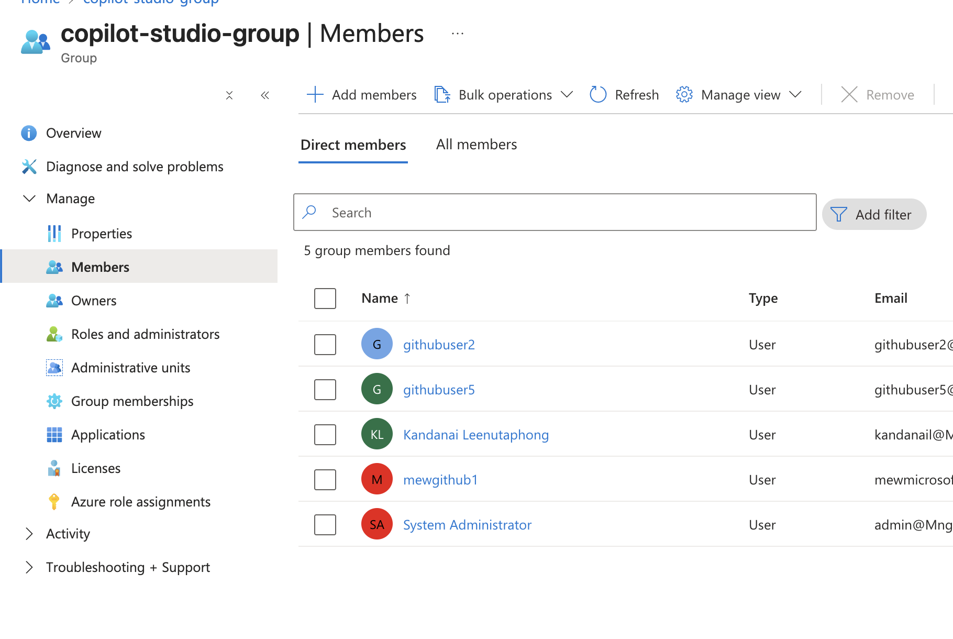

Navigate to http://admin.powerplatform.microsoft.com/, ensuring you have a powerplatform administrator to be able to see this page. (Note: log in with your admin account)
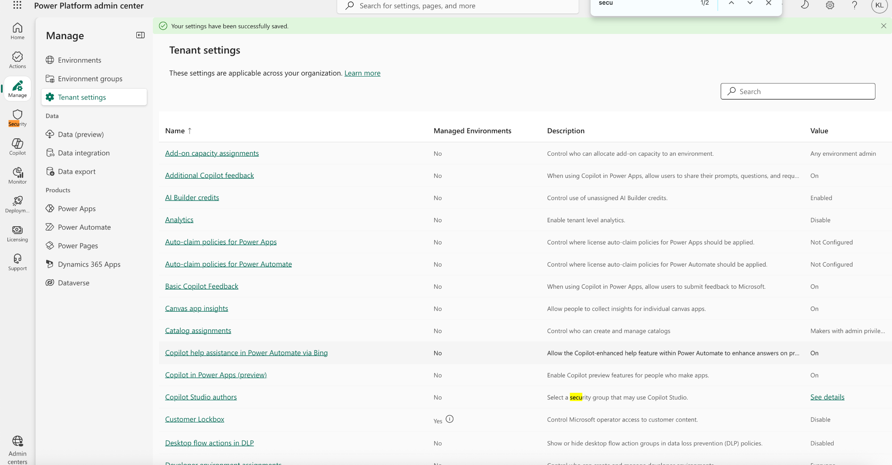

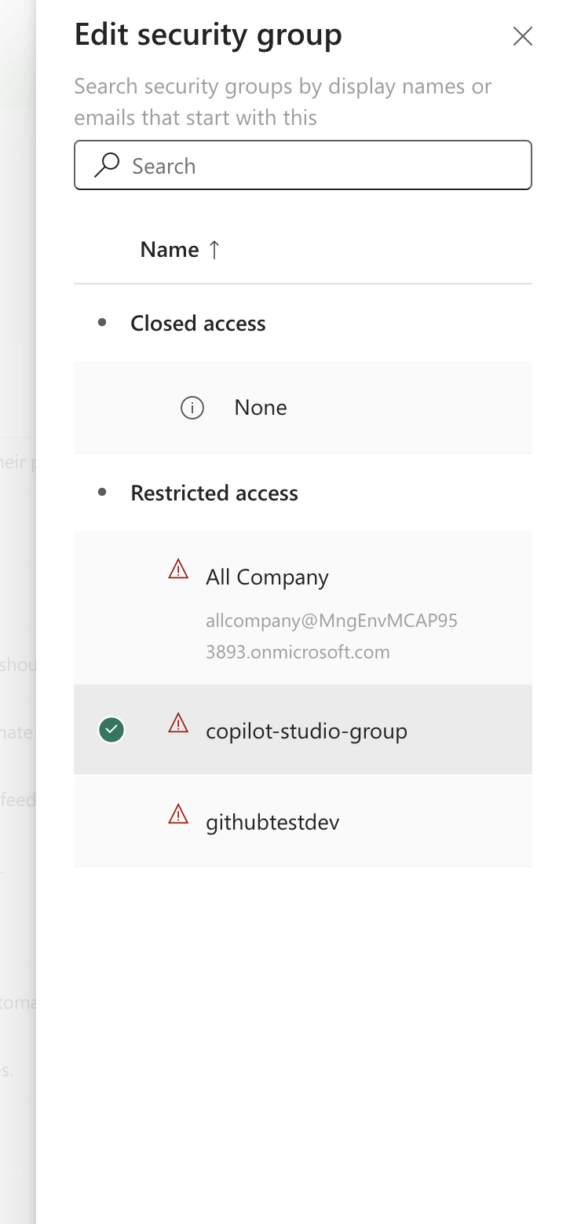

you need to wait up to 30 minutes. After 30 minutes log out and relogin again.
Lastly, Press publish. 🎉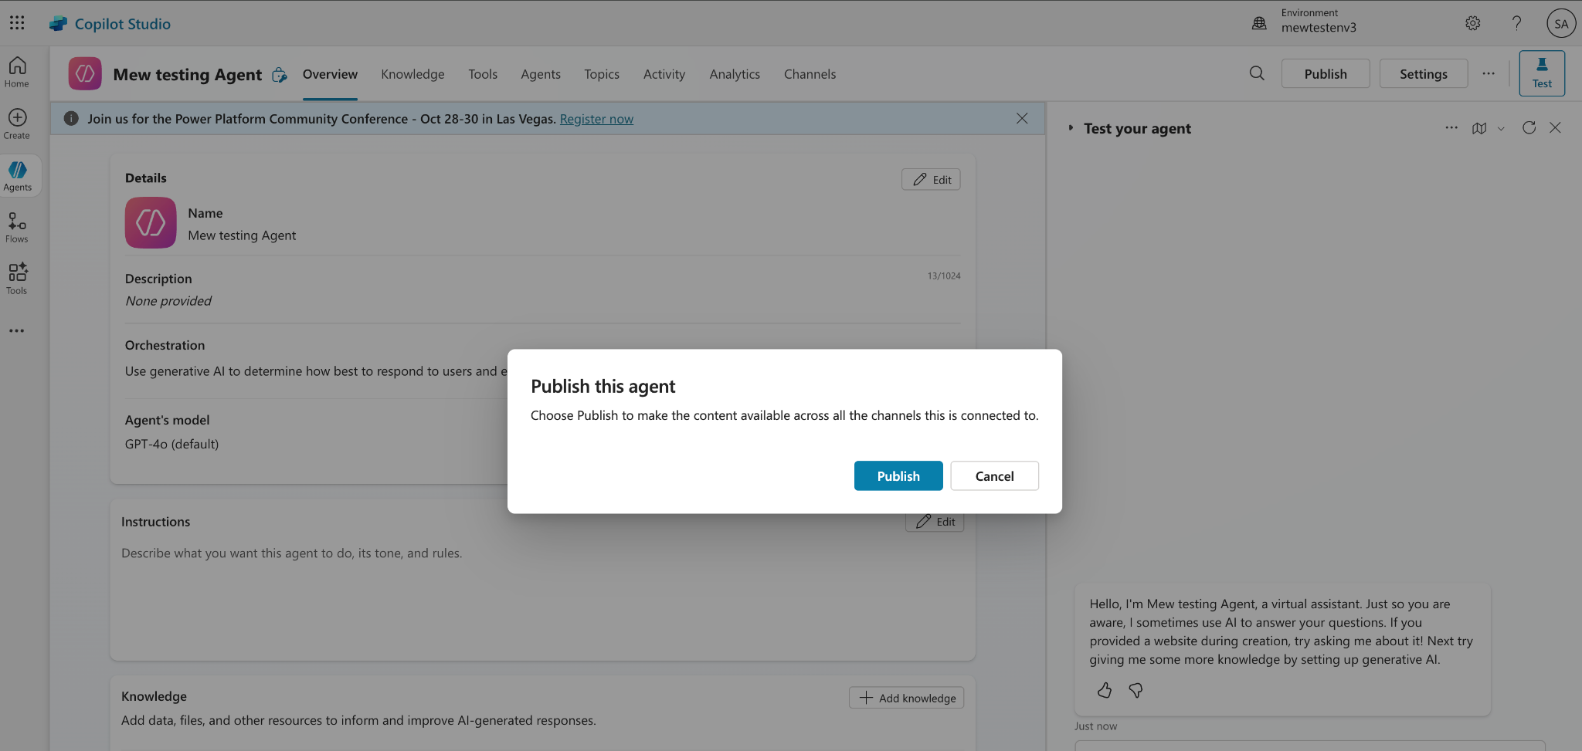

Now, let's say you want to publish an agent, but into a different user than the admin account. What do you do? Let's say there were githubuser7.

Requirement to add other user you must have
- Team license,
(Check at https://admin.microsoft.com)
- Added to the copilot agent environment inside power platform admins (http://admin.powerplatform.microsoft.com/)

Check Minimal license:
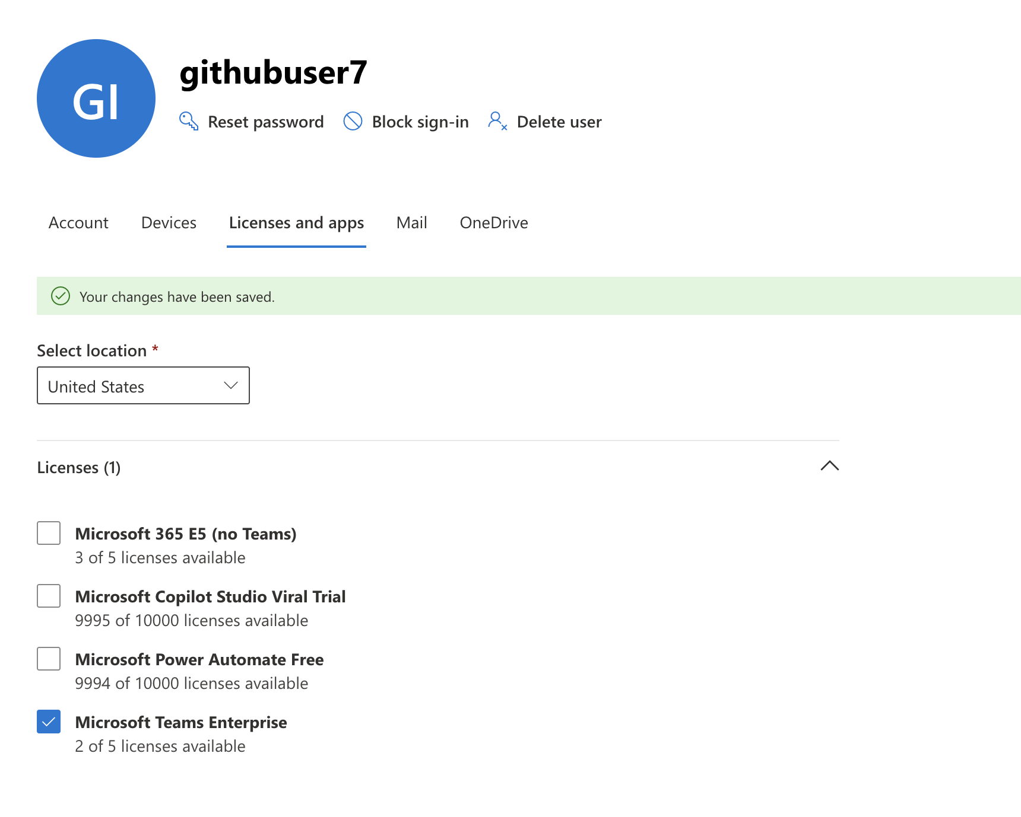
Registering new users to the copilot agent environment inside power platform admins. Navigate to manage -> environments -> Choose your environment -> settings -> users + permission -> users.
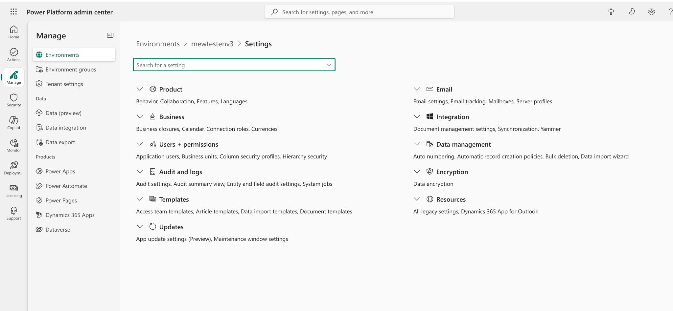
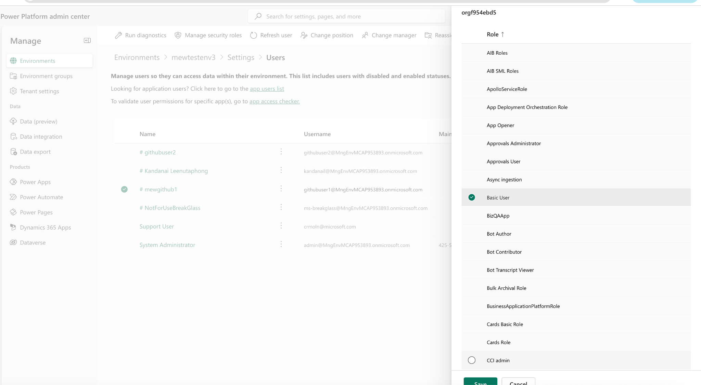
Add your user
And Add the following to be safe:
Basic User
Bot Author
Bot Contributor
Microsoft Copilot Administrator
Microsoft Copilot User
System Administrator

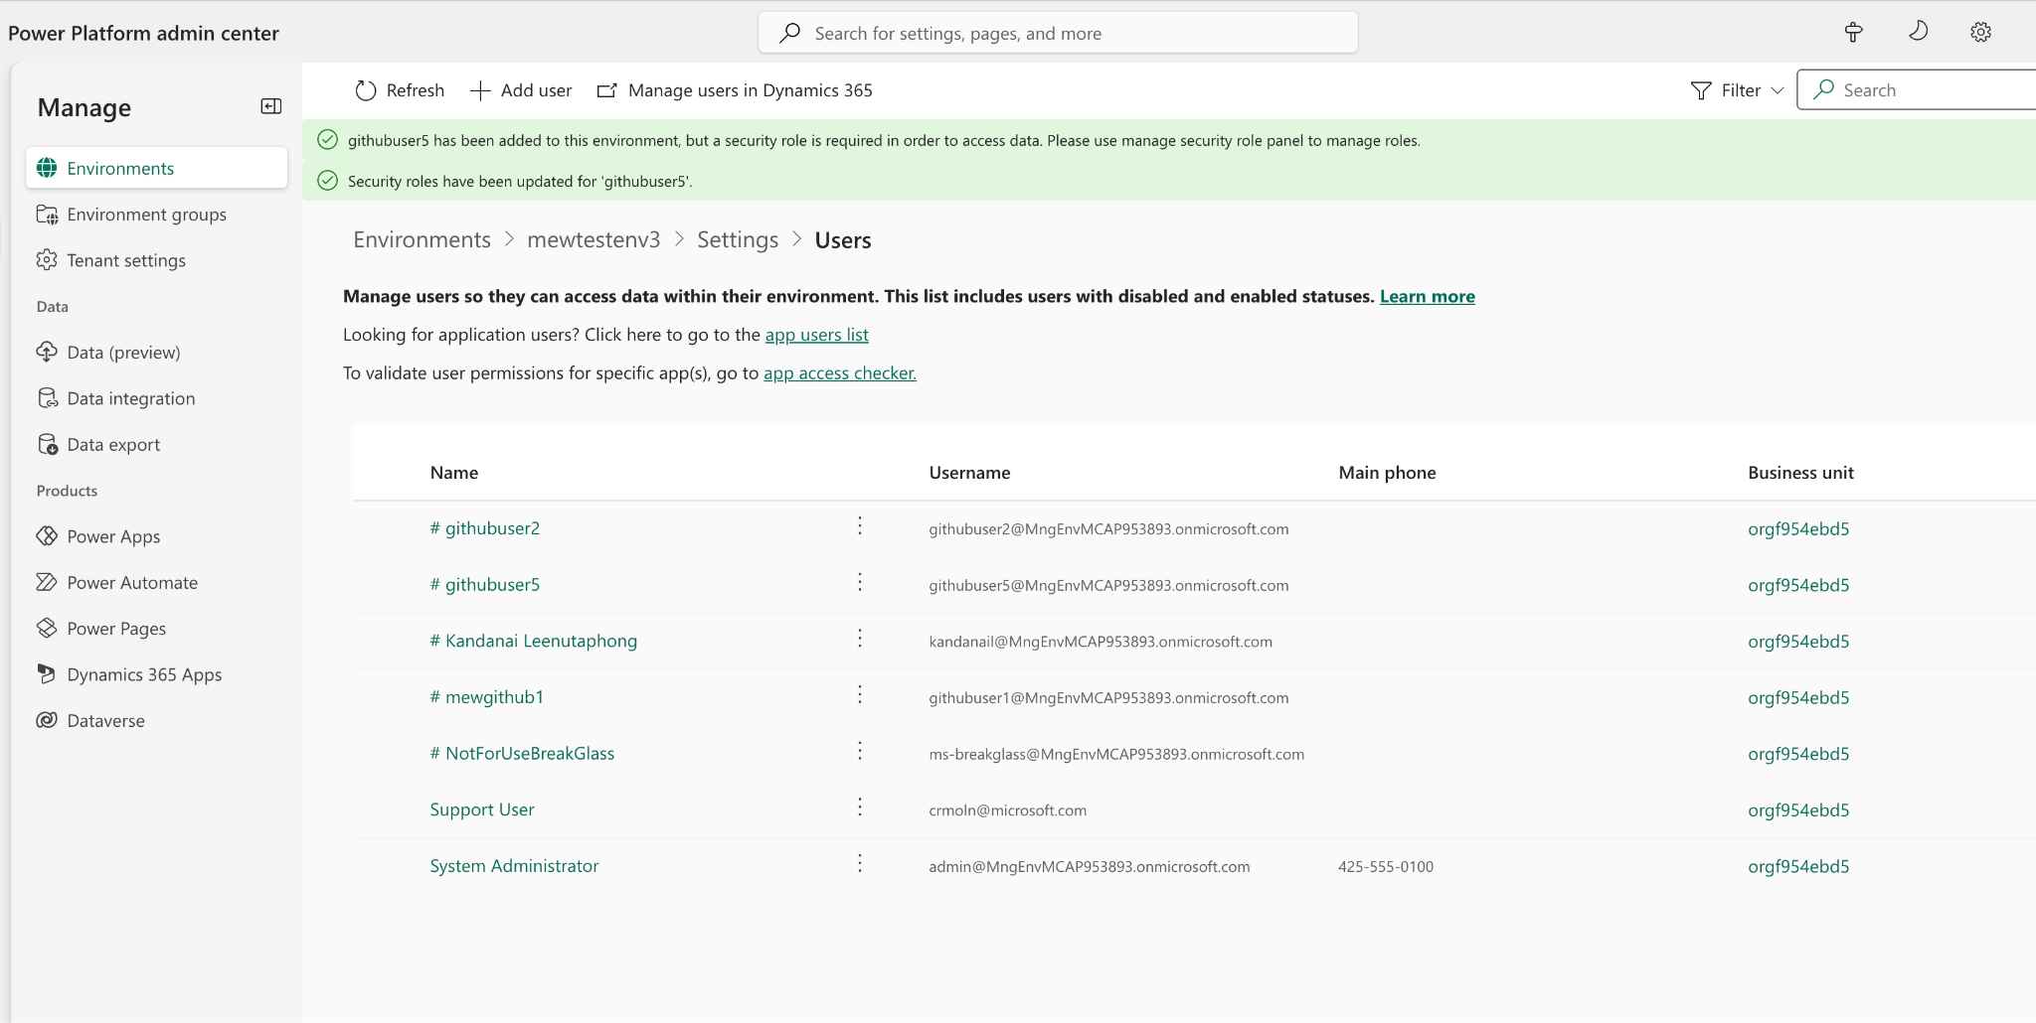

Refresh the user. Now, you can go ahead and get the published agent link and you should then be able to add published agents on teams in your new account.

You can get the link here:
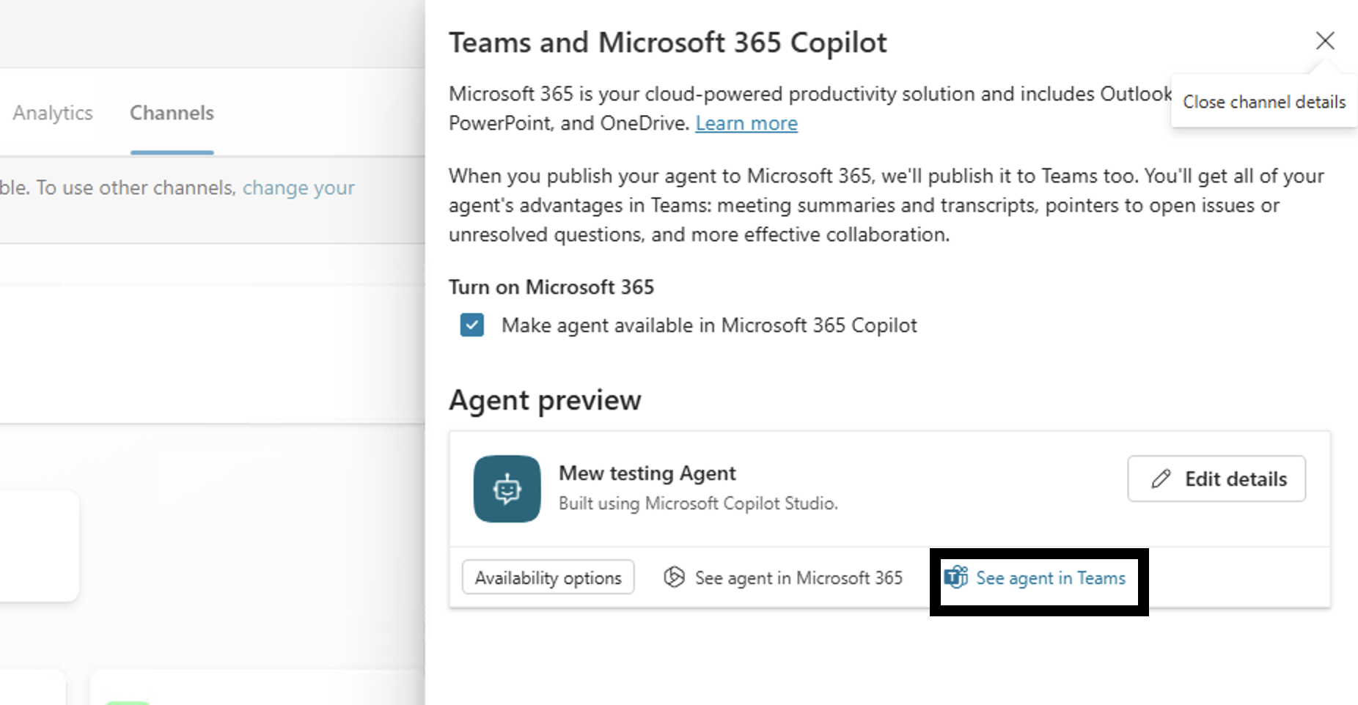
Or let the main developer share this link to you.
